DATE OF FUNCTION: _____________________________ Serial No.: LH/____/2019

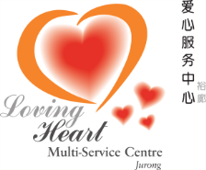
LOVING HEART MULTI-SERVICE CENTRE (JURONG)
Block 316 Jurong East Street 32 #01-279 Singapore 600316
Contact: 6567 4166 Fax: 6569 7957

DONATION & CONTRIBUTION FORM

Name of Donor / Organisation: ____________________________________________________________

Residential Address : _____________________________________________________________

_____________________________________________________________

Contact Person : _____________________________________________________________

Contact Number : ___________________________ (HP) _______________________ (O)

AMOUNT DONATED : $ ____________________________

Payment Type : CASH / CHEQUE Cheque No.: _____________________

Tax- Exempted Receipt : Yes / No Receipt No.: _____________________

Name of Function : _____________________________________________________________

Event Venue : _____________________________________________________________

Name of staff / Signature : _____________________________________________________________

Details / Information : _____________________________________________________________

DONATION / CONTRIBUTION RECEIVED BY:-

Name of Receiver / Signature: ____________________________________________________________

Designation : _____________________________________________________________

Date : _____________________________________________________________

Cash / Cheque Deposited on : _____________________________________________________________

